PE File Format(.NET)
Table of Contents
Introduce 2
PE File Format 2
DOS Header 2
NT Header 3
PE file header 3
Optional header 4
Standard fields 4
NT-specific fields 4
Data Directories 5
Section headers 5
.NET Extension 6
CLI Header 6
Metadata root 7
Stream 9
# GUID Stream 9
#Strings Stream 9
#US Stream 10
#Blob Stream 10
#~ Stream 11
Metadata Tables 12
Table Module:0x00 12
Table TypeRef:0x01 13
Table TypeDef:0x02 14
Table MethodDef:0x06 16
Table MemberRef:0x0A 18
Table CustomAttribute:0x0C 20
Table StandAloneSig:0x11 21
Table Assembly:0x20 22
Table AssemblyRef:0x23 23
Table MethodSpec:0x2B 24
References 24

Introduce
主要介绍由Unity引擎生成的Assembly-CSharp.dll等的文件格式。DLL文件本身是PE文件格式，利用IMAGE_DATA_DIRECTORY[15]实现对.NET的支持。本文以Unity引擎生成的一个DLL文件为例，详细解释各个字段的含义。
观察DLL文件格式的工具：010Editor,CFFExplorer。
一个标准的DLL文件有3个section，分别是.text .rsrc .reloc。.NET的元数据，IL代码和字符串存储在.text section里。
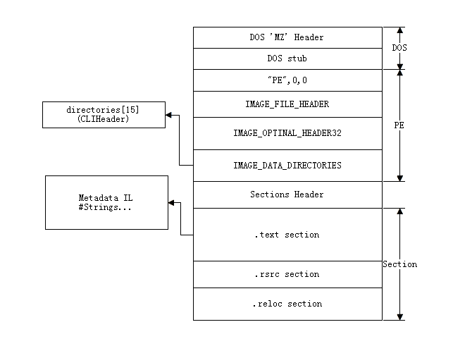

PE File Format
这里只介绍定位到.NET相关数据的字段。

DOS Header
// mono/metadata/cil-coff.h line:30
typedef struct {
char msdos_sig [2]; // 'MZ' 校验使用
guint16 nlast_page;
guint16 npages;
char msdos_header [54];
guint32 pe_offset; // +0x3c PE Header偏移
char msdos_header2 [64];
} MonoMSDOSHeader;
DOSHeader的内容位于文件开头，只关心pe_offset的值（+0x3c)，在本例中值是0x80。
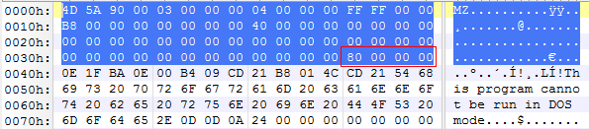

NT Header
/* 248 bytes */
typedef struct {
char pesig [4]; // PE.. 校验使用
MonoCOFFHeader coff;
MonoPEHeader pe;
MonoPEHeaderNT nt;
MonoPEDatadir datadir;
} MonoDotNetHeader;

PE file header
// mono/metadata/cil-coff.h line:40
/* 20 bytes */
typedef struct {
guint16 coff_machine; // always 0x14c
guint16 coff_sections; // number of sections importance!
guint32 coff_time;
guint32 coff_symptr; // always 0
guint32 coff_symcount; // always 0
guint16 coff_opt_header_size; // Size of the optional header
guint16 coff_attributes; // 0x2000 :DLL
} MonoCOFFHeader;
coff_machine:0x14c IMAGE_FILE_MACHINE_I386
coff_sections: 0x0003
coff_opt_header_size:0x00E0
Optional header 一个3部分组成 28 + 68 + 128 = 224 = 0xE0
coff_attributes:0x210E
0x210E = 0x0002 | 0x0004 | 0x0008 | 0x0100 | 0x2000
0x0002 IMAGE_FILE_EXECUTABLE_IMAGE
0x0004 IMAGE_FILE_LINE_NUMS_STRIPPED
0x0008 IMAGE_FILE_LOCAL_SYMS_STRIPPED
0x0100 IMAGE_FILE_32BIT_MACHINE
0x2000 IMAGE_FILE_DLL

Optional header
00 028 Standard fields
28 068 NT-speific fields
96 128 Data directories

Standard fields
// mono/metadata/cil-coff.h line:54
/* 28 bytes */
typedef struct {
guint16 pe_magic; // 0x20b:pe64; 0x10b:pe32 只考虑PE32
guchar pe_major;
guchar pe_minor;
guint32 pe_code_size;
guint32 pe_data_size;
guint32 pe_uninit_data_size;
guint32 pe_rva_entry_point;
guint32 pe_rva_code_base;
guint32 pe_rva_data_base;
} MonoPEHeader;
pe_magic:0x010B PE32
其他Fields不关心

NT-specific fields
// mono/metadata/cil-coff.h line:79
/* 68 bytes */
typedef struct {
guint32 pe_image_base; /* must be 0x400000 */
guint32 pe_section_align; /* must be 8192 */
guint32 pe_file_alignment; /* must be 512 or 4096 */
guint16 pe_os_major; /* must be 4 */
guint16 pe_os_minor; /* must be 0 */
guint16 pe_user_major;
guint16 pe_user_minor;
guint16 pe_subsys_major;
guint16 pe_subsys_minor;
guint32 pe_reserved_1;
guint32 pe_image_size;
guint32 pe_header_size;
guint32 pe_checksum;
guint16 pe_subsys_required;
guint16 pe_dll_flags;
guint32 pe_stack_reserve;
guint32 pe_stack_commit;
guint32 pe_heap_reserve;
guint32 pe_heap_commit;
guint32 pe_loader_flags;
guint32 pe_data_dir_count;
} MonoPEHeaderNT;
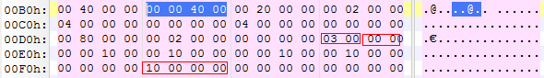
pe_dll_flags:0x0003 WINDOWS_CUI
pe_dll_flags:0x0000
pe_data_dir_count:0x00000010 PE文件都是16个Data Directories。这个Field很重要，外挂经常将这个Field修改成很大的值，导致ILSpy解析失败。

Data Directories
// mono/metadata/cil-coff.h line:193
typedef struct {
guint32 rva;
guint32 size;
} MonoPEDirEntry;

// mono/metadata/cil-coff.h line:199
/* 128 bytes */
typedef struct {
MonoPEDirEntry pe_export_table;
MonoPEDirEntry pe_import_table;
MonoPEDirEntry pe_resource_table;
MonoPEDirEntry pe_exception_table;
MonoPEDirEntry pe_certificate_table;
MonoPEDirEntry pe_reloc_table;
MonoPEDirEntry pe_debug;
MonoPEDirEntry pe_copyright;
MonoPEDirEntry pe_global_ptr;
MonoPEDirEntry pe_tls_table;
MonoPEDirEntry pe_load_config_table;
MonoPEDirEntry pe_bound_import;
MonoPEDirEntry pe_iat;
MonoPEDirEntry pe_delay_import_desc;
MonoPEDirEntry pe_cli_header;
MonoPEDirEntry pe_reserved;
} MonoPEDatadir;

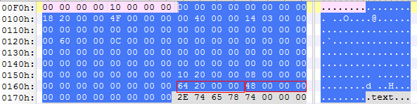
这里只关心pe_cli_header 表示CLI Header的位置
rva: 0x00002064
size: 0x00000048

Section headers
// mono/metadata/cil-coff.h line:257
typedef struct {
char st_name [8]; // An 8-byte,null-padded ASCII string
guint32 st_virtual_size; // Total size of the section in bytes
guint32 st_virtual_address; // the address when loaded into memory
guint32 st_raw_data_size; // Size of the data on disk in bytes
guint32 st_raw_data_ptr; // Offset of section's within the PE file
guint32 st_reloc_ptr;
guint32 st_lineno_ptr;
guint16 st_reloc_count;
guint16 st_line_count;

#define SECT_FLAGS_HAS_CODE 0x20
#define SECT_FLAGS_HAS_INITIALIZED_DATA 0x40
#define SECT_FLAGS_HAS_UNINITIALIZED_DATA 0x80
#define SECT_FLAGS_MEM_DISCARDABLE 0x02000000
#define SECT_FLAGS_MEM_NOT_CACHED 0x04000000
#define SECT_FLAGS_MEM_NOT_PAGED 0x08000000
#define SECT_FLAGS_MEM_SHARED 0x10000000
#define SECT_FLAGS_MEM_EXECUTE 0x20000000
#define SECT_FLAGS_MEM_READ 0x40000000
#define SECT_FLAGS_MEM_WRITE 0x80000000
guint32 st_flags;

} MonoSectionTable;

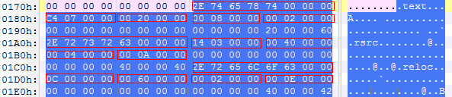
一共3个section,每个section的内容如下
Name VirtualSize RVA RawDataSize Offset
.text 0x000007C4 0x00002000 0x00000800 0x00000200
.rsrc 0x00000314 0x00004000 0x00000400 0x00000A00
.reloc 0x0000000C 0x00006000 0x00000200 0x00000E00

.NET Extension

CLI Header
// mono/metadata/cil-coff.h line:282
typedef struct {
guint32 ch_size;
guint16 ch_runtime_major;
guint16 ch_runtime_minor;
MonoPEDirEntry ch_metadata; // metadata

#define CLI_FLAGS_ILONLY 0x01
#define CLI_FLAGS_32BITREQUIRED 0x02
#define CLI_FLAGS_STRONGNAMESIGNED 0x8
#define CLI_FLAGS_TRACKDEBUGDATA 0x00010000
guint32 ch_flags; // flags

guint32 ch_entry_point; // Entry Token
MonoPEDirEntry ch_resources; // Resource
MonoPEDirEntry ch_strong_name; // StrongName
MonoPEDirEntry ch_code_manager_table;
MonoPEDirEntry ch_vtable_fixups;
MonoPEDirEntry ch_export_address_table_jumps;

/* The following are zero in the current docs */
MonoPEDirEntry ch_eeinfo_table;
MonoPEDirEntry ch_helper_table;
MonoPEDirEntry ch_dynamic_info;
MonoPEDirEntry ch_delay_load_info;
MonoPEDirEntry ch_module_image;
MonoPEDirEntry ch_external_fixups;
MonoPEDirEntry ch_ridmap;
MonoPEDirEntry ch_debug_map;
MonoPEDirEntry ch_ip_map;
} MonoCLIHeader;

如何计算CLI Header在文件中的偏移？
第1步：在本例中CLI Header的内容是（参考PE file data directories）：
rva: 0x00002064
size: 0x00000048

第2步：根据Section header内容，可知CLI header位于.text section中
.text section rva start :0x00002000
.text section rva end: 0x000027C4

0x00002000 <= 0x00002064 < 0x000027C4

第3步：计算文件中的偏移
offset = 0x00000200 + （0x00002064 – 0x00002000) = 0x00000264
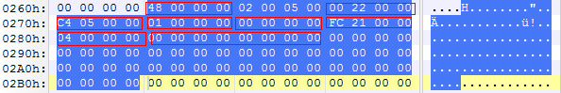
ch_size: 0x00000048
ch_metadata: (0x00002200,0x000005C4)
ch_flags:0x00000001 CLI_FLAGS_ILONLY
ch_entry_point:0x00000000
ch_resources:(0x000021FC,0x00000004)
ch_strong_name:(0x00000000,0x00000000) 该DLL没有Strong Name

Metadata

Metadata root
参考ECMA-335 Partition II 24.2.1
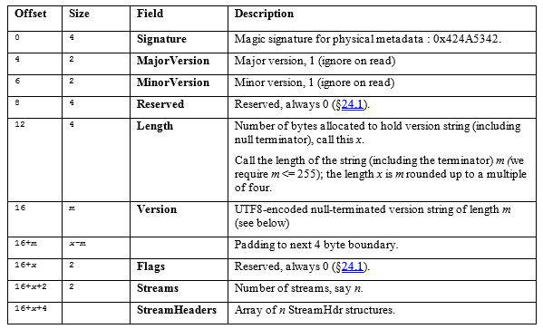
计算metadata root在文件的偏移
offset = 0x200 + (0x2200 – 0x2000) = 0x400
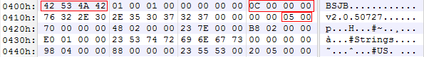
Signature:BSJB 修改为其他值，ILSpy解析失败
Length:0x0000000C
Version:v2.0.50727 // 4字节对齐
Streams:0x0005 // 流的个数，外挂经常修改，实现加密

Stream header
参考ECMA-335 Partition II 24.2.2
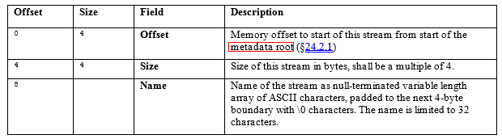
Stream header紧接着Metadata root的，一个有5个流：
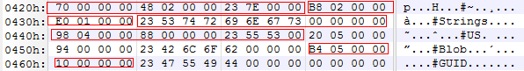
Name Offset Size
#~ 0x00000070 0x00000248
#Strings 0x000002B8 0x000001E0
#US 0x00000498 0x00000088
#Blob 0x00000520 0x00000094
#GUID 0x000005B4 0x00000010

这里的Offset是相对于Metadata root的偏移，如何计算在文件中的偏移？
比如#Strings流：Metadata root在文件中的偏移是0x400（上面已经计算过），那么该流在文件中的偏移是0x400 + 0x02B8 = 0x6B8。

Stream
流简介
- #Strings ：UTF8格式的字符串堆，包含各种元数据的名称（比如类名、方法名、成员名、参数名等）。流的首部总有一个0作为空字符串，各字符串以0表示结尾。CLR中这些名称的最大长度是1024。
- #Blob：二进制数据堆，存储程序中的非字符串信息，比如常量值、方法的signature、PublicKey等。每个数据的长度由该数据的前1～3位决
定：0表示长度1字节，10表示长度2字节，110表示长度4字节。
- #GUID：存储所有的全局唯一标识（Global Unique Identifier）。
- #US ：以Unicode格式存放的IL代码中使用的用户字符串（User String），比如ldstr调用的字符串。
- #~“：

# GUID Stream
存储所有的全局唯一标识（Global Unique Identifier）。
文件中的偏移 offset = 0x400 + 0x5B4 = 0x9B4

#Strings Stream
UTF8格式的字符串堆，包含各种元数据的名称（比如类名、方法名、成员名、参数名等）。流的首部总有一个0作为空字符串，各字符串以0表示结尾。CLR中这些名称的最大长度是1024。
文件中的偏移offset = 0x400 + 0x2B8 = 0x6B8
通过加密该流，达到加密DLL的目的
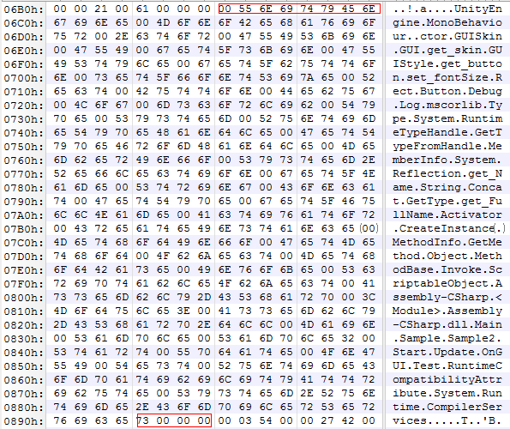

#US Stream
以Unicode格式存放的IL代码中使用的用户字符串（User String），比如ldstr调用的字符串。
文件中的偏移offset = 0x400 + 0x498 = 0x898

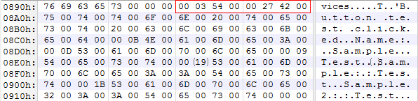
#Blob Stream
二进制数据堆，存储程序中的非字符串信息，比如常量值、方法的signature、PublicKey等。每个数据的长度由该数据的前1～3位决定：0表示长度1字节，10表示长度2字节，110表示长度4字节。
offset: 0x400 + 0x520 = 0x920
size:0x94
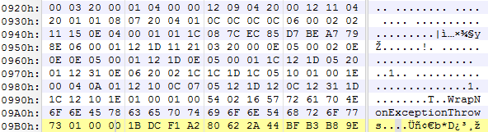

#~ Stream
元数据表流，最重要的流，几乎所有的元数据信息都以表的形式保存于此。每个.Net程序都必须包含。
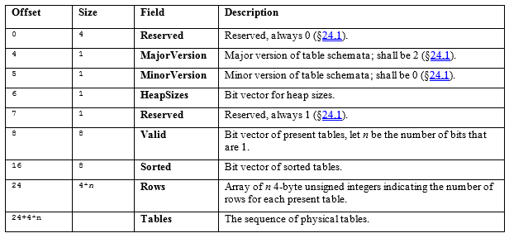
文件中的偏移offset = 0x400 + 0x070 = 0x470
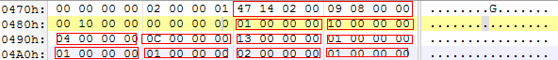
HeapSizes: 00
定位数据时索引的大小。
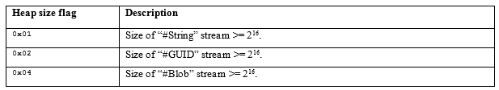
0x00 & 0x01 = 0 表示#Strings 索引大小为16位，如果为1表示索引大小为32位
0x00 & 0x02 = 0 表示#GUID索引大小为16位，如果为1表示索引大小为32位
0x00 & 0x04 = 0 表示#Blob索引大小为16位，如果为1表示索引大小为32位

Sorted: 0x 00 00 00 00 00 00 10 00
8字节长度的掩码，每个位代表一个表，为1表示该表已排序。
Valid: 0x 00 00 08 09 00 02 14 47
0b 0000,0000,0000,0000,0000,1000,0000,1001,0000,0000,0000,0010,0001,0100,0100,0111
8字节长度的掩码，每个位代表一个表，为1表示该表存在。
本例中一个有10个位为1，表示存在10张表，紧跟后面的10个4字节整数表示每张表有多少行。下面详细介绍是哪10张表。每个位表示那张表，参考ECMA-335 Partition II 22。

Metadata Tables
Metadata is stored in two kinds of structure: tables (arrays of records) and heaps. There are four heaps in any module: String, Blob, Userstring, and Guid. The first three are byte arrays (so valid indexes into these heaps might be 0, 23, 25, 39, etc). The Guid heap is an array of GUIDs, each 16 bytes wide. Its first element is numbered 1, its second 2, and so on.
程序集(Assembly) 可能包含多个模块，一般情况下只有一个主模块
模块Module 可以包含多个类型
类型(TypeDef) 包含字段，方法，属性，事件
字段（Field)
方法（Method)
属性(Property)
事件(Event)
类型引用（TypeRef）该程序集依赖的类型
程序集依赖（AssemblyRef)
紧接表头，是10张表的内容

Table Module:0x00
The Module table has the following columns:
- Generation (a 2-byte value, reserved, shall be zero)
- Name (an index into the String heap)
- Mvid (an index into the Guid heap; simply a Guid used to distinguish between two versions of the same module)
- EncId (an index into the Guid heap; reserved, shall be zero)
- EncBaseId (an index into the Guid heap; reserved, shall be zero)
0x00000001 表示该表只有一行
在介绍#~表头的时候，可以知道#String,#GUID,#Blob的索引大小是2字节。所以Name,Mvid,EncId,EncBaseId的索引都是2字节。
Name Index: 0x0160
#Strings 在文件中的偏移为0x6B8
offset = 0x6B8 + 0x160 = 0x818 strings(0x818) = “Assembly-CSharp.dll”
Mvid: 0x0001
PS： GUID的索引从1开始。
// Example Code:
class ModuleDefinition
{
guint32 name;
guint32 mvid;
}
// utilities.cs
public static MetadataToken GetMetadataToken (this CodedIndex self, uint data)

Table TypeRef:0x01
0x00000010 表示该表有16行
The TypeRef table has the following columns:
- ResolutionScope (an index into a Module, ModuleRef, AssemblyRef or TypeRef table, or null; more precisely, a ResolutionScope (§24.2.6) coded index)
- TypeName (an index into the String heap)
- TypeNamespace (an index into the String heap)
ResolutionScope 可能是2字节，也可能是4字节,如何判断？
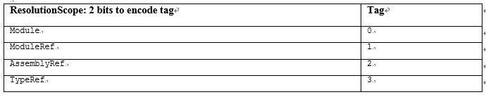
ResolutionScope 的低2位表示属于哪张表，其余位表示该表的哪一行。它可能属于4张表中的任何一个。
如果 MaxRow(Module,ModuleRef,AssemblyRef,TypeRef) > 1<<14 : 4字节
否则：2字节
本例中所有表的大小都小于 2^14 ，所以ResolutionScope占用2字节。
TypeName和TypeNamespace 都占用2字节，每行大小6字节，16 * 6 = 0x60
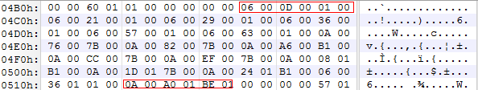
第1行
ResolutionScope:0x0006 0b 01,10 AssemblyRef 第一行 UnityEngine.dll
TypeName:0x000D strings(0x6B8+0x0D=0x6C5) = “MonoBehaviour”
TypeNamespace:0x0001 strings(0x6B8+0x01=0x6B9) = “UnityEngine”
类UnityEngine.MonoBehaviour 在程序集UnityEngine.dll里。
第16行
ResolutionScope:0x000A 0b10,10 AssemblyRef 第二行：mscorlib.dll
TypeName:0x01A0 strings(0x6B8 + 0x01A0=0x858) = “RuntimeCompatibilityAttribute”
TypeNamespace:0x01BE strings(0x6B8 + 0x01BE=0x876) = “System.Runtime.CompilerServices”

Table TypeDef:0x02
The TypeDef table has the following columns:
- Flags (a 4-byte bitmask of type TypeAttributes, §23.1.15)
- TypeName (an index into the String heap)
- TypeNamespace (an index into the String heap)
- Extends (an index into the TypeDef, TypeRef, or TypeSpec table; more precisely, a TypeDefOrRef (§24.2.6) coded index)
- FieldList (an index into the Field table; it marks the first of a contiguous run of Fields owned by this Type).The run continues to the smaller of:
- the last row of the Field table
- the next run of Fields, found by inspecting the FieldList of the next row in this TypeDef table
- MethodList (an index into the MethodDef table; it marks the first of a continguous run of Methods owned by this Type). The run continues to the smaller of:
- the last row of the MethodDef table
- the next run of Methods, found by inspecting the MethodList of the next row in this TypeDef table
简要说明：Extends表示该类型的父类型，FieldList 表示属于该类型的所有Fields的开始位置，结束位置由下一个TypeDef里的FieldList决定，MethodList也是这样。
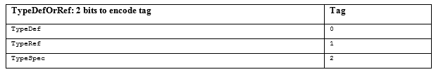
0x00000004 表示该表有4行
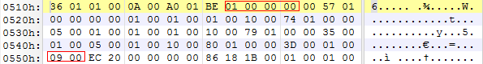
第一行
Flags:0x00000000 NotPublic => internal
TypeName: 0x0157 strings(0x6B8+0x157=0x80F)=”<Module>”
TypeNamespace: 0x0000 strings(0x6B8) = “”
Extends:0x0000 不继承任何类型
FieldList:0x0001 下一行与之相减为0，表示没有Field
MethodList:0x0001 下一行与之相减为0，表示没有Method
internal class <Module>
{
}
第二行
Flags:0x00100001 BeforeFieldInit | Public
TypeName: 0x0174 strings(0x6B8+0x174)=”Main”
TypeNamespace: 0x0000 strings(0x6B8) = “”
Extends:0x0005 0b 01,01 表示TypeRef第一行 继承MonoBehaviour
FieldList:0x0001 下一行与之相减为0，表示没有Field
MethodList:0x0001 下一行与之相减为4，表示有4个Method
public class Main:MonoBehaviour
{
}
第三行
Flags:0x00100001 BeforeFieldInit | Public
TypeName: 0x0179 strings(0x6B8+0x179) = “Sample”
TypeNamespace: 0x0000
Extends:0x0035 0b 0011 01,01 TypeRef的第13行 System.Object
FieldList:0x0001 下一行与之相减为0，表示没有Field
MethodList:0x0005 下一行与之相减为4，表示有4个Method
public class Sample:System.Object
{
}
第四行
Flags:0x00100001 BeforeFieldInit | Public
TypeName: 0x0180 strings(0x6B8+0x180=0x838)=”Sample2”
TypeNamespace: 0x0000
Extends:0x003D 0b 0011 11,01 TypeRef的第15行 UnityEngine.ScriptableObject
FieldList:0x0001 下一行与之相减为0，表示没有Field
MethodList:0x0009 从第9行到结束
public class Sample2:ScriptableObject
{
}

Table MethodDef:0x06
The MethodDef table has the following columns:
- RVA (a 4-byte constant)
- ImplFlags (a 2-byte bitmask of type MethodImplAttributes, §23.1.10)
- Flags (a 2-byte bitmask of type MethodAttributes, §23.1.10)
- Name (an index into the String heap)
- Signature (an index into the Blob heap)
- ParamList (an index into the Param table). It marks the first of a contiguous run of Parameters owned by this method. The run continues to the smaller of:
- the last row of the Param table
- the next run of Parameters, found by inspecting the ParamList of the next row in the MethodDef table

0x0000000C 表示该表有12行
start : 0x552
size：12 * 14 = 0xA8
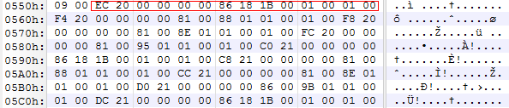
只看前4行
Method:名字，参数，返回值，方法体
row 1
RVA:0x000020EC offset(il) = 0x200 + 0x0EC = 0x2EC
ImplFlags: 0x0000 IL | Managed
Flags:0x1886 Public|HideBySig|SpecialName|RTSpecialName
Name:0x001B strings(0x6B8+0x01B) = .ctor
Signature:0x0001

#Blob 00 03 20 00 01
03 & 0x80 == 0 长度用1个字节表示，数据长度为3
<method_sig> ::= <callconv_method> <num_of_args><return_type>
20 MAGE_CEE_CS_CALLCONV_HASTHIS instance
00 0个参数
01 VOID
ParamList:0x0001 0个参数

row 2
RVA:0x000020F4
ImplFlags: 0x0000 IL|Managed
Flags:0x0081 Private|HideBySig
Name:0x0188 strings(0x6B8+0x188) = Start
Signature:0x0001
ParamList:0x0001
row 3
RVA:0x000020F8
ImplFlags: 0x0000 IL|Managed
Flags:0x0081 Private|HideBySig
Name:0x018E strings(0x6B8 + 0x18E) = Update
Signature:0x0001
ParamList:0x0001 0个参数
row 4
RVA:0x000020FC
ImplFlags: 0x0000 IL|Managed
Flags:0x0081 Private|HideBySig
Name:0x0195 strings(0x6B8 + 0x188) = OnGUI
Signature:0x0001
ParamList:0x0001 0个参数

备注：
HideBySig :Sig + Name => Only Name
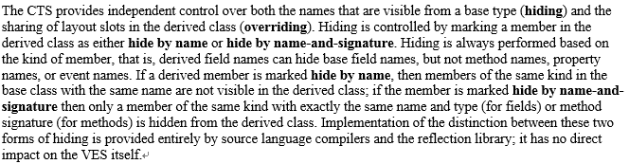
# Blob
二进制数据堆，存储程序中的非字符串信息，比如常量值、方法的签名、公钥等。每个数据的长度由该数据的前1-3位决定：0表示长度1字节，10表示长度2字节，110表示长度4字节。

Table MemberRef:0x0A
The MemberRef table combines two sorts of references, to Methods and to Fields of a class, known as ‘MethodRef’ and ‘FieldRef’, respectively.The MemberRef table has the following columns:
- Class (an index into the MethodDef, ModuleRef,TypeDef, TypeRef, or TypeSpec tables; more precisely, a MemberRefParent (§24.2.6) coded index)
- Name (an index into the String heap)
- Signature (an index into the Blob heap)
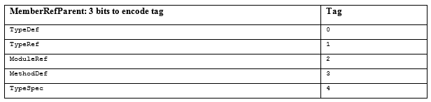
Class 用低3位表示是哪一张表。
0x00000013 表示该表有19行
start : 0x552 + 0xA8 = 0x5FA
size: 19 * 6 = 0x72
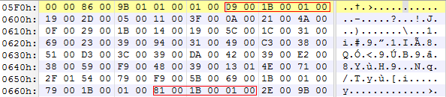
row 1
Class : 0x0009 0b 1,001 TypeRef 1 MonoBehaviour
Name: 0x001B .ctor
Signature: 0x0001 SIG:03 20 00 01
20 instance 方法
00 0个参数
01 返回值 VOID
row 2
Class : 0x0019 0b 01 1,001 TypeRef 3 UnityEngine.GUI
Name: 0x002D get_skin
Signature: 0x0005 SIG:04 00 00 12 09
00 Normal 方法
00 0个参数
返回值：0x12 表示Class 应该是TypeDefOrRef，一个压缩整数09 0b 10,01，TypeRef的第2行 UnityEngine.GUISkin
函数全名 UnityEngine.GUISkin UnityEngine.GUI::get_skin()
row 3
Class : 0x0011 0b 01 0,001 TypeRef 2 UnityEngine.GUISkin
Name: 0x003F get_button
Signature: 0x000A 04 20 00 12 11
0x20 Instance方法
00 0个参数
12 表示Class 11 0b 0001 00,01 TypeRef 第4行 UnityEngine.GUIStyle
UnityEngine.GUIStyle UnityEngine.GUISkin::get_button()
row 4
Class : 0x0021 0b 010 0,001 TypeRef 4 UnityEngine.GUIStyle
Name: 0x004A set_fontsize
Signature: 0x000F 04 20 01 01 08
20
01 一个参数
01 VOID
08 参数类型 I4 32位整数
void UnityEngine.GUIStyle::set_fontsize(int32)
row 5
Class : 0x0029 0b 0010 1,001 TypeRef 5 UnityEngine.Rect
Name: 0x001B .ctor
Signature: 0x0014 SIG: 0x07 20 04 01 0C 0C 0C 0C
20
04 4个参数
01 void
0C R4 float32
void UnityEngine.Rect::.ctor(float32,float32,float32,float32)
row 6
Class : 0x0019 TypeRef 3 UnityEngine.GUI
Name: 0x005C Button
Signature: 0x001C 06 00 02 02 11 15 0E
00 normal static
02 2个参数
02 Boolean
0x11 ValueType 0x15 0b 0001 01,01 TypeRef 第5行 UnityEngine.Rect
0x0E string
bool GUI::Button(UnityEngine.Rect,string)
row 7
Class : 0x0031 0b 0011 0,001 TypeRef 6 UnityEngine.Debug
Name: 0x0069 Log
Signature: 0x0023 04 00 01 01 1C
00 normal static method
01
01 void
1C System.Object
void Debug.Log(System.Object)
row 8
Class : 0x0039 0b 0011 1,001 TypeRef 7 System.Type
Name: 0x0094 GetTypeFormHandle
Signature: 0x0031 06 00 01 12 1D 11 21
00 static normal
01 1个参数
12 class 1D 0b 0001 11,01 TypeRef 第7行 System.Type
11 value type 21 0b 0010 00,01 System.RuntimeTypeHandle
System.Type System.Type::GetTypeFromHandle(System.RuntimeTypeHandle)
row 9
Class : 0x0049 0b 0100 1,001 TypeRef 9 System.Reflection.MemberInfo
Name: 0x00C3 get_Name
Signature: 0x0038 03 20 00 0E
20 instance
00
0E string
string System.Relection.MemberInfo::get_Name();

row 19
Class 0x0081 0b 1000 0,001 TypeRef 16 RuntimeCompatibilityAttribute
Name 0x001B .ctor
Signature 0x0001 03 20 00 0E
void System.Runtime.CompilerServices.RuntimeCompatibilityAttribute::.ctor()

Table CustomAttribute:0x0C
The CustomAttribute table has the following columns:
- Parent (an index into any metadata table, except the CustomAttribute table itself; more precisely, a HasCustomAttribute (§24.2.6) coded index)
- Type (an index into the MethodDef or MemberRef table; more precisely, a CustomAttributeType (§24.2.6) coded index)
- Value (an index into the Blob heap)
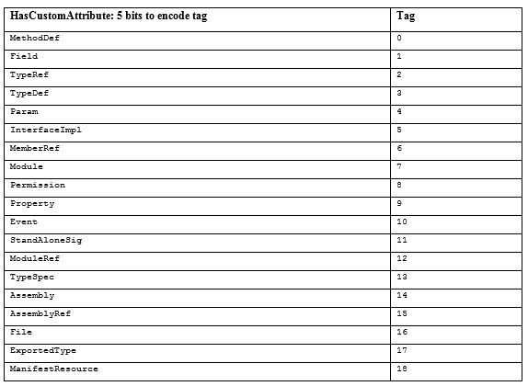
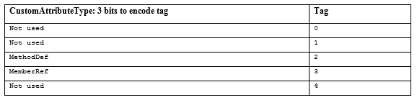
0x00000001 表示该表有1行
start: 0x5FA + 0x72 = 0x66C
Parent: 002E 0b 001,0 1110 Assembly table 1 row : Assembly-CSharp.dll
Type 009B 0b 1001 1,011 MemberRef table 19 row
Value:0073 Blob index
1E 01 00 01 00 54 02 16 57 72 61 70 4E 6F 6E 45 78 63 65 70 74 69 6F 6E 54 68 72 6F 77 73 01 00 00
RuntimeCompatibilityAttribute instance 序列化的值

Table StandAloneSig:0x11
The signature shall describe either:
- a method – code generators create a row in the StandAloneSig table for each occurrence of a calli CIL instruction. That row indexes the call-site signature for the function pointer operand of the calli instruction
- local variables – code generators create one row in the StandAloneSig table for each method, to describe all of its local variables. The .locals directive (§15.4.1) in ILAsm generates a row in the StandAloneSig table.
TheStandAloneSig table has the following column:
- Signature (an index into the Blob heap)

0x00000001 表示该表有1行
Signature 0x00 66

0C 07 05 12 1D 12 0C 12 31 1D 1C 12 10
MAGE_CEE_CS_CALLCONV_LOCAL_SIG 0x7
Local Variables Signature
<locals_sig> ::= <callconv_locals> <num_of_vars> <var_type>
05
12 1D 0b 0001 11,01 TypeRef 7 row System.Type
12 0C 0b 0000 11,00 TypeDef 3 row Sample
12 31 0b 0011 00,01 TypeRef 12 row System.Relection.MethodInfo
1D 1C 1D : SZARRAY <type>[] 1C object => object[]
12 10 0b 0001 00,00 TypeDef 4 row Sample2

等价的.locals指令
.locals init(
[0] class [mscorlib] System.Type
[1] class Sample,
[2] class [mscrolib]System.Relection.MethodInfo,
[3] object[],
[4] class Sample2
)

Table Assembly:0x20
The Assembly table has the following columns:
- HashAlgId (a 4-byte constant of type AssemblyHashAlgorithm, §23.1.1)
- MajorVersion, MinorVersion, BuildNumber, RevisionNumber (each being 2-byte constants)
- Flags (a 4-byte bitmask of type AssemblyFlags, §23.1.2)
- PublicKey (an index into the Blob heap)
- Name (an index into the String heap)
- Culture (an index into the String heap)

0x00000001 表示该表有1行
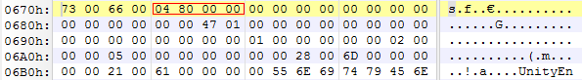
HashAlgId 00 00 80 04 SHA1
MajorVersion 00 00
MinorVersion 00 00
BuildNumber 00 00
RevisionNumber 00 00
Flags 00 00 00 00
PublicKey 00 00
Name 01 47 Assembly-CSharp
Culture 00 00

Assembly的名字不带扩展名

Table AssemblyRef:0x23
The AssemblyRef table has the following columns:
- MajorVersion, MinorVersion, BuildNumber, RevisionNumber (each being 2-byte constants)
- Flags (a 4-byte bitmask of type AssemblyFlags, §23.1.2)
- PublicKeyOrToken (an index into the Blob heap, indicating the public key or token that identifies the author of this Assembly)
- Name (an index into the String heap)
- Culture (an index into the String heap)
- HashValue (an index into the Blob heap)
0x00000002 表示该表有2行
offset :0x068A
size : 40B 0x28
row 1
MajorVersion 00 00
MinorVersion 00 00
BuildNumber 00 00
RevisionNumber 00 00
Flags 00 00 00 00
PublicKeyOrToken 00 00
Name 00 01 UnityEngine
Culture 00 00
HashValue 00 00

row 2
MajorVersion 00 02
MinorVersion 00 00
BuildNumber 00 05
RevisionNumber 00 00 2.0.5.0
Flags 00 00 00 00
PublicKeyOrToken 00 28 08 7C EC 85 D7 BE A7 79
Name 00 6D mscorlib
Culture 00 00
HashValue 00 00

Table MethodSpec:0x2B
The MethodSpec table has the following columns:
- Method (an index into the MethodDef or MemberRef table, specifying to which generic method this row refers; that is, which generic method this row is an instantiation of; more precisely, a MethodDefOrRef (§24.2.6) coded index)
- Instantiation (an index into the Blob heap (§23.2.15), holding the signature of this instantiation)
主要描述泛型方法实例化
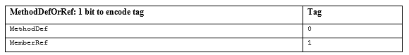
0x00000001 表示该表有1行
offset:0x06B2
Method :0x0021 0010 000,1 MemberRef 16 row
UnityEngine.ScriptableObject::CreateInstance
Instantiation:0x0061
04 0A 01 12 10
IMAGE_CEE_CS_CALLCONV_GENERICINST (0x0A)
<gen_method_inst_sig> ::= <callconv_inst> <num_of_type_args>
<type_arg_type>[,<type_arg_type>]*

01 1个类型参数
12 10 表示类型 12 表示是Class类型 0b 0001 00,00 TypeDef 4 Row Sample2
==> 代码里会有类似调用
ScriptableObject::CreateInstance<Sample2>()

References
ECMA 355 Partition II
Expert .NET 2.0 IL Assembler Table 8-1. Primitive Data Types Defined in the Runtime

